student1 & student2

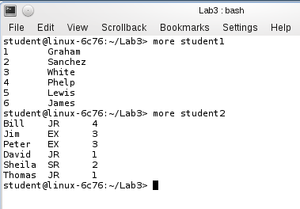

**paste student1 student2 > student_paste**

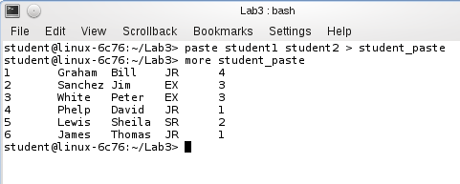

**cat student1 student2 > student_cat**

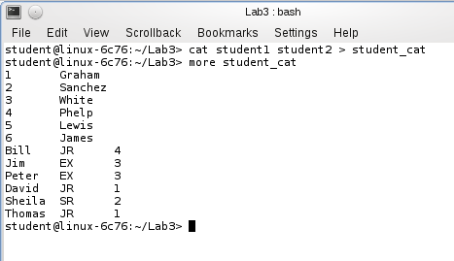

**cut -f3 student_paste** //-f3 means field 3

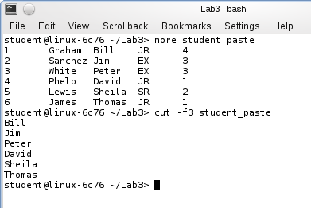

**cat student_paste | tr ‘\t’ ‘,’ > student_paste_comma**

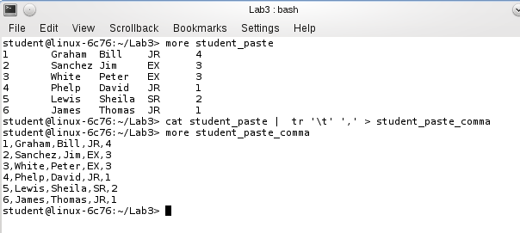

**cut -f2,3,4 -d ',' student_paste_comma**

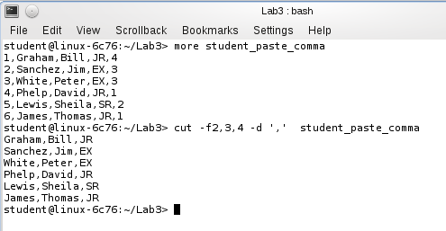

**cut -f3 student_paste > studenttest1**

**cut -f4 student_paste > studenttest2**

**paste studenttest1 studenttest2 > studentdata**

**sort studentdata**

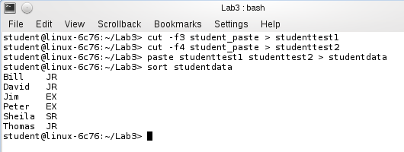

**vi studentscript**

**cut -f3,4 student_paste**

**chmod 711 studentscript** //give studentscript executive permission

**./studentscript**  //executive studentscript

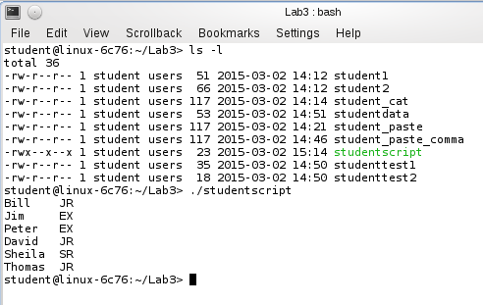

**more student_paste**

**sort -k5 student_paste > student_paste_sort_k5**

**join -a 1 -1 5 -2 1 student_paste_sort_k5 faculty**

**join -a 1 -1 3 -2 5 faculty_reverse student_paste_sort_k5**

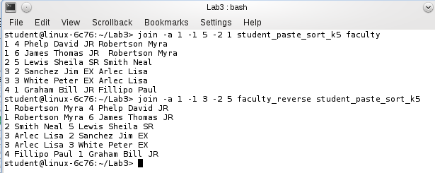

**awk 'BEGIN {**

**{print "\t\t Student at Vanier\n"}**

**{"date" | getline d}**

**{printf "\t %s\n", d}**

**{printf "Student LName\t\t\t Student FName\n"}**

**{print "==============================================="}**

**}**

**{printf " %-8s\t\t\t %s\n",$2,$3}' student**

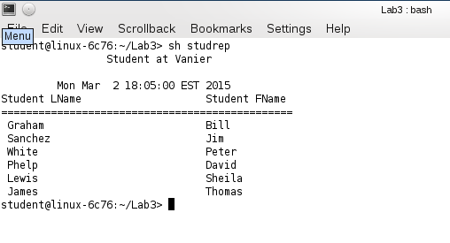

Project.4.-10

**cat product1 product2**

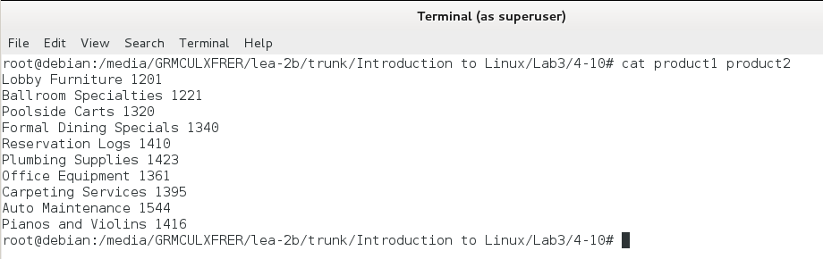

Project.4-12

**cut -f4-6 -d: corp_phones1**

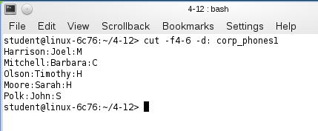

**cut -c14-25,26-35,36 corp_phones2**

